*Candidate’s Name: …………………………………………………………………………...*

*Signature: …………………………………*

*545/1 CHEMISTRY*

*Paper 1*

*2024*

*2 hours*

*DAAR SSALAAM SECONDARY SCHOOL*

*FORM TWO END OF TERM II*

*CHEMISTRY DEPARTMENT EXAMINATIONS BOARD*

*Uganda Certificate of Education CHEMISTRY*

*Paper 1*

*2 hours*

*INSTRUCTIONS TO CANDIDATES:*

*This paper has 2 examination items which are compulsory*

*Answer in the space provided*

*ITEM 1*

The Uganda Civil Aviation Authority has hired an engineering company to reconstruct the recently damaged bombardier aircraft body. The chief engineer of the company wants to reconstruct a new, good and strong bombardier aircraft body.

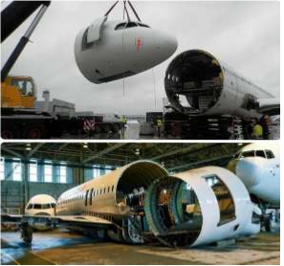

However the chief engineer knows that he has to choose the right material to be used with suitable qualities and properties and thus he has come to you for advice.

Task:

Use your chemistry knowledge to;

1. Explain (i) The category of the material the engineering company will use ______________________________________________________________________________________________________________________________________________________________________________________________________
2. (ii) The suitability of the material ________________________________________________________________________________________________________________________________________________________________________________________________________________________________________________________________________________________________________________________________________________________________________________________
3. (b) The impact of the material to the environment. __________________________________________________________________________________________________________________________________________________________________________________________________________________________________________________________________________________________

**Item 2.**

Mwine, is a renowned environmental advocate. He is thinking of installing the door and window frames for his house under construction.

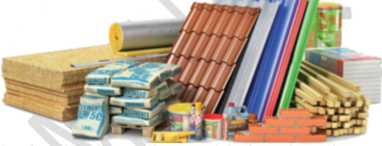

He knows that to have good quality frames, he should select the right materials with suitable qualities and properties. Mwine, is still confused with the choice and has approached you for some advice.

**Task**

Use your knowledge of chemistry to:

1. Explain
   1. the categories of materials

………………………………………………………………………………………………………………………………………………………………………………………………………………………………………………………………………………………………………………………………………………………………………...

* 1. the suitability of the materials

…………………………………………………………………………………………………………………………………………………………………………………………………………………………………………………………………………...

1. Advise Mwine on the choice of materials

………………………………………………………………………………………………………………………………………………………………………………………………………………………………………………………………………………………………………………………………………………………………………………………………

END